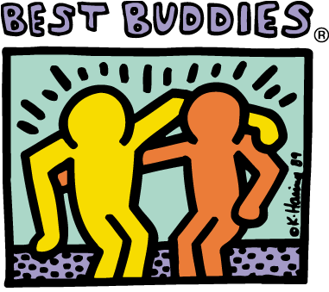
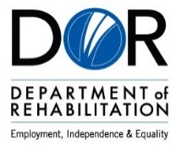

Project Search Intern Application

Application Purpose & Guidelines

The purpose of this application packet is to outline the skill sets of the Project SEARCH intern candidate. This application enables the Selection Committee to properly assess each candidate’s skills, abilities and background. References may be contacted by the Selection Committee to gather additional information. Our final goal is to select individuals who will be successful in a Project SEARCH program and reach the outcome of competitive employment.

Project SEARCH will run from August 1,2021-May 5,2022

Submit the completed application by May 1, 2022 to

Central Valley Regional Center, David Keosheyan, Employment Specialist 4615 N. Marty, Fresno CA, 93722-4186 or dkeosheyan@cvrc.org

The applicant may be required to pass a criminal background check and/or drug screen.

Project SEARCH requirements:
- Applicant must be between ages 20 and 39. Ages 20-22 must have a HS Diploma
- Applicant must meet eligibility requirements for Central Valley Regional Center (CVRC) and the Department of Rehabilitation (DOR).
- Applicant must have independent personal hygiene and grooming skills.
- Applicant must have independent daily living skills.
- Applicant must maintain appropriate behavior and social skills in the classroom and workplace.
- Applicant must take direction to change behavior.
- Applicant must be able to communicate effectively.
- Applicant must have the desire to explore transportation options, including public transportation when available, and to be trained to travel independently.
- Applicant must have the ability to pass a drug screen and felony check.
- Applicant must have immunizations up to date.
- Applicant must have the desire to work competitively at the conclusion of the Project SEARCH program.
- Applicant must be willing to enroll in Continuing Education through Fresno Pacific University.

Project SEARCH Application Packet Check list

The purpose of this application packet is to outline the skill set of the Project SEARCH intern. Please include the following with your application:
- Completed Application Packet
- Exit Individual Education Plan (IEP) including Transition Goals (if available)
- Documentation of any formal training, i.e. Workability, Employment training
(If applicable)
- Copy of Health Insurance card
- Current Photo
- Copy of Birth Certificate or State ID or Driver’s License
- Copy of Social Security card or tax payer ID

Application

PERSONAL DATA
Name: _____________________________________________________________________
Last First Middle
SS#: _________________ Date of Birth: _____________ Male Female

Address: _____________________________________________________________________
Street City Zip
Phone number: ______________________ Email__________________________________

Service Coordinator: ___________________________________________________________
Emergency Contact Name: ______________________________________________________
Address: _____________________________________________________________________
Street City Zip
Emergency Contact Home Phone: ________________ Cell Phone: __________________
EMPLOYMENT BACKGROUND:
List jobs you do or have done in school or in the community:
Employer/Organization | Job Title | Job Duties | Supervisor Name | Dates | Contact Number | Paid | Un-  paid

Have you ever been fired from a job?
Yes |  | No

If yes, please explain:

Have you ever quit a job?
Yes |  | No

If yes, please explain:

After the Project SEARCH program is completed, do you plan on getting and maintaining a
Full time job |  |  | or a Part time job?
Where or with what kind of Organization? |  |  |  | How many days/hours per week?
Where do you plan on living? | Home |  |  | Friends Other _____

TRANSPORTATION:
How do you plan to get to Project SEARCH?

INDEPENDENT LIVING
List any side effects of medications that may affect an internship or employment:
____________________________________________________________________________
____________________________________________________________________________
List any health or medical conditions that may affect job placement:

Please list any limitations that may affect an internship rotation or employment:

BEHAVIORAL SUMMARY:
Do you have any behaviors that might affect a successful job placement?
Yes |  | No

Please Explain:

Application Response Question
Why do you want to participate to Project SEARCH? (Applicant must complete)

List Three References (Non-Related):
 | Name | Association to you | Phone Number | Email Address
1.
2.
3.

Name of person who assisted with this application (if applicable):

Name | Title | Phone Number | Date

Signature

